Create an assignment in Microsoft Teams
Microsoft Teams for Education
Create assignments for your students in Microsoft Teams. Manage assignment timelines, instructions, adding resources to turn in, and more.
Note: The Assignments tab is only available in class teams.
- Navigate to the General channel in the desired classroom, then select Assignments.
- Select Create>Assignment.
- 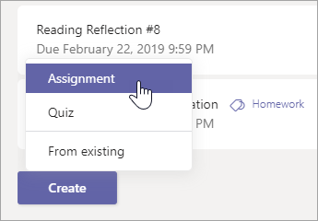
- Enter a title for this assignment—this is required.
- Provide more information for the assignment. The following steps are optional:
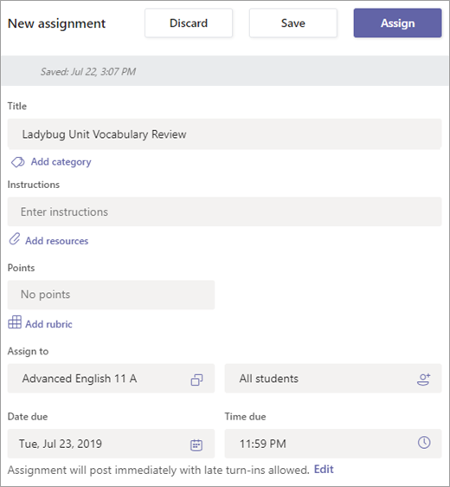
  - Choose multiple classes or individual students in one class to assign to.
  - Add additional instructions
  - Attach resources to the assignment by selecting Add resources.
During this step, add a document from your personal OneDrive, computer, or create a blank Word (.docx), Excel (.xlsx), or PowerPoint (.pptx) document to hand out to your students.
  - The default for the file will be Students can't edit, which means the document is read-only. This is a great option for reference materials.
  - Select More options > Students edit their own copy if you'd like each student to edit their own document and turn it in for a grade.
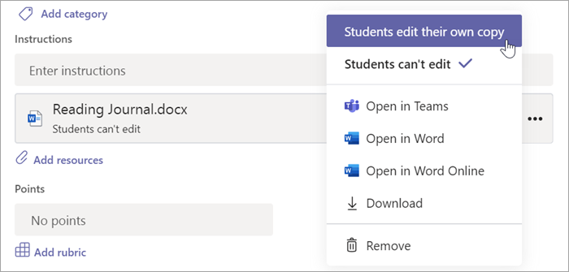
  - Notes:
    - If you're assigning a Class Notebook page, check to see what version of OneNote your students are using to ensure that their assignment pages will lock after the assignment due date passes.
    - If you have older documents with the file extension .doc, .xls, or .ppt, students won't be able to edit them. You can either attach them as read-only reference material or create a new file in Teams. Copy in the old content and save. Your new file will have the updated .docx, .xlsx, and .pptx file extension. All new files you create in Teams or other Office 365 apps will have the correct extension.
  - Select a due date and time.
For more assignment timeline options, select Edit. Here, you can customize when your assignment will be posted to students and when it will close for turn-ins. By default, no close date will be selected, which allows students to turn in assignments late.
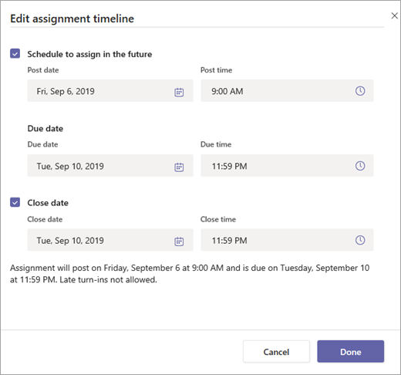
  - Select the amount of points this assignment is worth, if any. You can use points on any number-based scale including whole numbers of 100 and set your own denominator. Examples: 88/100 or decimals 3.7/4.0.
  - Select Add rubric to add a grading rubric.
  - Add a category.
- Select Assign. Your students will be notified of the new assignment on the day you specified.
- Select Discard to discontinue work on this assignment or Save to return to the assignment and edit it later.
- Note: Select Expand tab (diagonal, double sided arrow) to enter full-screen mode.

